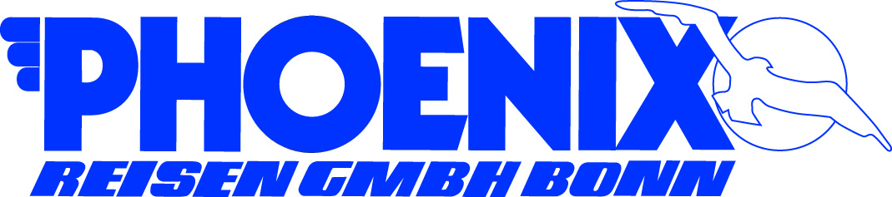**PORT QUESTIONNAIRE**

|  |  |  |  |
| --- | --- | --- | --- |
| Port: | BOSTON | Arrival Time: | 9:00 |
| Ship: | ARTANIA | Departure Time: | 22:00 |
| Date: | April 24, 2018 - Tuesday | Public Holiday: | NO |
| **Name & Address of Port** | | **Name/No. of expected Berth** | |
| BLACK FALCON CRUISE TERMINAL | |  | |
| 1 Black Falcon Ave | | TBA | |
| Boston, MA 02210 | |  | |

|  |  |  |  |  |  |  |
| --- | --- | --- | --- | --- | --- | --- |
| PORT FACILITIES | N | Bank | N | Post | Y | Tourist Info |
| *(Please mark with Y or N)* | Y | Telephone | N | Internet | Y | Taxi (on street) |

|  |  |  |
| --- | --- | --- |
| Telephone Country Code and City Code | Dial out code to Germany: | Postage fee to Germany  (postcard / letter) |
| 00 1 (617) | 011 49 | USD $ 1.15 |
| Local Time (GMT +/- hrs) | Languages | Crime Rate |
| + 6 hours | ENGLISH | Average - low in City Center |
| Temperature (in Celsius) | Humidity | Recommended Clothing |
| Average: Low 11 - High 16 | Average Relative: 69 % | jacket, sweater, comfortable walking shoes |

|  |  |  |  |  |  |  |  |
| --- | --- | --- | --- | --- | --- | --- | --- |
| Nearest Bank/  Exchange Office: | Banking Hrs. | | Currency | | € 1 = | US$ 1 = | |
| Bank of America  60 State Street | 9:00 – 16:30 | | USD | | EUR 1.00 | USD 1.18 as per July 2017 | |
| Accepted Payments | Y | Only local currency | | Y | Cash in US$ | N | Cash in € |
| *(Please mark with Y or N)* | Y | Credit Cards (please specify): Master Card, Visa Card, American Express, some Diners Club. | | | | | |
|  | N | Maestro/Debit Card (only if USA bank account) | | | | | |

|  |  |  |  |  |
| --- | --- | --- | --- | --- |
|  | City Center | Beach | Airport | Train Station |
| Name of: | Boston | Winthrop Shore | Logan Int’l | Massachusetts Bay Commuter Railroad Company |
| Distance in km: | 3.9 km | 12.2 km | 6.4 km | 2.5 km |
| Taxi fare to: | $ 15.00 | $ 16 | $ 15.00 | $ 5 -$7 |

|  |  |  |
| --- | --- | --- |
|  | Where: | Business/Opening Hours: |
| Tourist Information | At the Black Falcon Cruise Terminal / Public Garden | 9:00 – 17:00 |
| Post Office | 25 Dorchester Ave, rm 1  Boston, MA 02205 | 6:00 – 12:00 |
| Internet Café | Any Starbucks has internet access / no real internet cafe’s in Boston | 6 :15 – 21 :00 |
| Shopping | City Center: Quincy Market, Faneuil Hall, Newbury Street shopping, Copley Place Mall, Haymarket | 12:00 – 18:00 |
| Museums | Museum of Fine Arts and Museum of Science | 10:00 – 16:45 |
| Restaurants | Durgin Park, The Oyster House, Legal Sea Food, Om and Cheers Bar, The Chart House, No Name restaurant | 11 :00 – 22 :00 |
| Places of interest: | Faneuil Market Place, Freedom Trail. Fenway Park, North End, Prudential sky walk Observe., Back Bay, Waterfront, New England Aquarium, River Charles etc. | 10:00 – 20:00 |

|  |  |  |  |  |  |  |
| --- | --- | --- | --- | --- | --- | --- |
| Shore leave for pax… *(Please mark with Y or N)* | Y | …with Landing Card | Y | with Passport  recommended | N | Customs & Immigrations |

|  |  |
| --- | --- |
| Typical Souvenirs: | Boston Tea Party replicas, Plates with Boston pictures & logos, Harvard and MIT T Shirts, Boston tea shirts, mugs, magnets, plates |
| Special Remarks: | Boston has a lot of history specially related to the US Independence. Therefore a city tour is a must to learn about the places & people as well as see the city that will remind you of back home – a town from Europe specially its cobalt, red brick streets and architecture. |